Spectral coherence: USDJPY and EURGBP
Method 21 / daily log returns / Welch magnitude-squared coherence / Alpari D1 full available history

Study setup
Logical pair: USDJPY , EURGBP
Broker symbols: USDJPY_i , EURGBP_i
Snapshot: 2026-11-03_majors_alpari_D1
Timeframe: D1
Matched return window: 1999-01-06 to 2026-11-02 (UTC bar dates)
Matched return count n: 7181
Dropped unfinished last bar dated 2026-11-03 UTC after a tick-volume check against the prior complete day.
Welch: fs=1.0, nperseg=256, noverlap=128, window=hann, detrend=constant
Headline: gamma^2 nearest f=1/5; also 1/21 and 1/63
Complete matched rows (Excel): USDJPY-EURGBP_Spectral_D1.xlsx
Complete matched rows (HTML table): USDJPY-EURGBP_Spectral_D1_data.html

Method carried forward
Magnitude-squared spectral coherence gamma^2(f) measures shared linear power between matched daily log returns of close, ln(close_t / close_t-1), at each frequency f (cycles per day). Quotes are not inverted. Welch settings are frozen: fs=1, nperseg=256, noverlap=128, window=hann, detrend=constant. Headline is gamma^2 at the frequency bin nearest f=1/5 (five-day cycle from the formula sheet). Also reported: gamma^2 nearest f=1/21 and f=1/63, mean gamma^2 over the frequency grid, and phase of the cross-spectrum at the 1/5 bin. Coherence is unsigned (0 to 1); phase carries timing. Same-sample Pearson r is a side check only. This is not causation and not a trading signal.

Results (headline)
gamma^2 near 1/5: 0.019296
bin f (1/5): 0.199219
phase at 1/5 (rad): 2.538198
gamma^2 near 1/21: 0.106748
gamma^2 near 1/63: 0.038089
mean gamma^2: 0.043805
Pearson r: -0.127992

Target-frequency summary
period | target_f | f_bin | gamma2 | phase_rad
5 | 0.2 | 0.19921875 | 0.01929608 | 2.5381983
21 | 0.04761905 | 0.046875 | 0.10674817 | 2.666407
63 | 0.01587302 | 0.015625 | 0.03808881 | -2.152844

Conclusion
Headline gamma^2 near f=1/5 for USDJPY and EURGBP: 0.0193 (bin f=0.199219, phase=2.5382 rad). At ~1/21: 0.1067; at ~1/63: 0.0381. Mean gamma^2 = 0.0438. Pearson r = -0.1280. This is frequency-domain linkage, not a trading signal.

Charts
Daily closes

Daily log returns

Spectral coherence gamma^2(f)
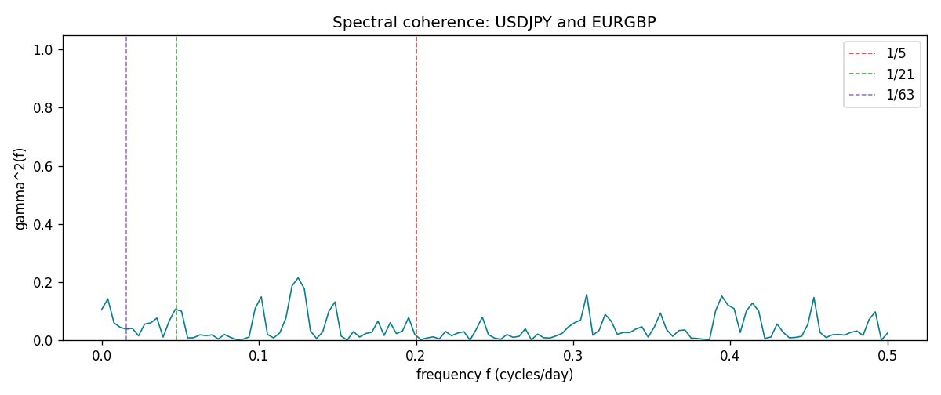

Data report
Matched rows and the coherence sheet are in the sibling Excel workbook named USDJPY-EURGBP_Spectral_D1.xlsx. Embedding all rows as a Word table is impractical; this file holds column summaries and the first and last 15 matched rows.
Columns: time, USDJPY_open, EURGBP_open, USDJPY_high, EURGBP_high, USDJPY_low, EURGBP_low, USDJPY_close, EURGBP_close, USDJPY_tick_volume, EURGBP_tick_volume, USDJPY_spread, EURGBP_spread, USDJPY_real_volume, EURGBP_real_volume, USDJPY_log_return, EURGBP_log_return
Column summaries (matched calculation rows)
column | count | mean | std | min | 25% | 50% | 75% | max
USDJPY_open | 7181 | 113.80773 | 19.228846 | 75.693 | 104.38 | 110.98 | 120.71 | 163.824
EURGBP_open | 7181 | 0.78701429 | 0.09663819 | 0.5734 | 0.6877 | 0.83392 | 0.86523 | 0.9769
USDJPY_high | 7181 | 114.30513 | 19.290536 | 76.001 | 104.865 | 111.439 | 121.27 | 163.978
EURGBP_high | 7181 | 0.79009197 | 0.09701345 | 0.5789 | 0.6897 | 0.83701 | 0.8681 | 0.9799
USDJPY_low | 7181 | 113.28458 | 19.156841 | 75.402 | 103.87 | 110.53 | 120.172 | 163.628
EURGBP_low | 7181 | 0.78431381 | 0.09645598 | 0.5682 | 0.6857 | 0.83166 | 0.86287 | 0.9661
USDJPY_close | 7181 | 113.82069 | 19.244339 | 75.811 | 104.38 | 111.015 | 120.695 | 163.851
EURGBP_close | 7181 | 0.78705735 | 0.09663932 | 0.5735 | 0.6878 | 0.83401 | 0.86539 | 0.977
USDJPY_tick_volume | 7181 | 106398.86 | 179473.16 | 149 | 9958 | 53207 | 92916 | 1803508
EURGBP_tick_volume | 7181 | 87156.048 | 145513.65 | 154 | 6593 | 44384 | 81451 | 1424684
USDJPY_spread | 7181 | 20.250104 | 17.60648 | 0 | 6 | 11 | 30 | 50
EURGBP_spread | 7181 | 21.316669 | 19.115948 | 0 | 4 | 13 | 40 | 50
USDJPY_real_volume | 7181 | 3.4800425e+10 | 1.6097887e+11 | 0 | 0 | 0 | 0 | 3.8834203e+12
EURGBP_real_volume | 7181 | 2.788005e+10 | 1.3523257e+11 | 0 | 0 | 0 | 0 | 3.5726265e+12
USDJPY_log_return | 7181 | 4.847e-05 | 0.00620794 | -0.03908203 | -0.00320533 | 0.00011473 | 0.00340924 | 0.05184024
EURGBP_log_return | 7181 | 2.133e-05 | 0.00487349 | -0.03067367 | -0.00262366 | -0.00010035 | 0.00255918 | 0.06075387
First 15 matched rows (selected columns)
time | USDJPY_log_return | EURGBP_log_return
1999-01-06 | 0.0075660159 | -0.013303338
1999-01-07 | -0.012851583 | 0.011051402
1999-01-08 | -0.0047719894 | -0.004943862
1999-01-11 | -0.016195423 | -0.0012752393
1999-01-12 | 0.032310364 | 0.0033970309
1999-01-13 | 0.0081373171 | 0.00042381861
1999-01-14 | 0 | -0.0019793588
1999-01-15 | 0.0055343401 | -0.0076715819
1999-01-18 | 8.7600193e-05 | 0.00071280921
1999-01-19 | -0.0056219403 | -0.0014261269
1999-01-20 | -0.0053879917 | 0.0019960086
1999-01-21 | 0.0084664056 | -0.00071240297
1999-01-22 | 0.0060412564 | -0.0017118406
1999-01-25 | -0.0073594164 | -0.0054402425
1999-01-26 | 0.0012303367 | -0.00057438255
Last 15 matched rows (selected columns)
time | USDJPY_log_return | EURGBP_log_return
2026-10-13 | -0.0018932826 | 0.00020130374
2026-10-14 | 7.5800166e-05 | 0.0011241873
2026-10-15 | -0.0018524319 | -0.00087557391
2026-10-16 | -0.00037976126 | -0.0020380844
2026-10-19 | 0.0034946841 | -0.00056950988
2026-10-20 | -0.0022546642 | -0.0035906254
2026-10-21 | -0.00032883504 | -0.00140647
2026-10-22 | -0.0085942669 | -0.0018743924
2026-10-23 | 0.00035080446 | 0.00082421033
2026-10-26 | 0.0041238746 | 0.00013133309
2026-10-27 | 0.0027651658 | -0.0019957343
2026-10-28 | -0.00095679538 | 0.00066967224
2026-10-29 | -0.00038043789 | -0.0011722209
2026-10-30 | -0.0010596481 | -0.0024205543
2026-11-02 | 0.0026438521 | 0.00089940465
First 15 frequency bins
f | gamma2 | phase_rad | period_days
0 | 0.10558432 | 3.1415927 | inf
0.00390625 | 0.14210264 | 2.6069651 | 256
0.0078125 | 0.05979327 | -3.0630354 | 128
0.01171875 | 0.04448681 | -2.3549043 | 85.333333
0.015625 | 0.03808881 | -2.152844 | 64
0.01953125 | 0.04092782 | -2.5350663 | 51.2
0.0234375 | 0.01508192 | 3.08875 | 42.666667
0.02734375 | 0.05543568 | 2.8710105 | 36.571429
0.03125 | 0.05968928 | 2.9198313 | 32
0.03515625 | 0.07615506 | -3.0266448 | 28.444444
0.0390625 | 0.01074914 | -2.8611235 | 25.6
0.04296875 | 0.06592773 | 2.5999448 | 23.272727
0.046875 | 0.10674817 | 2.666407 | 21.333333
0.05078125 | 0.09979821 | 3.1047758 | 19.692308
0.0546875 | 0.00811416 | 2.6913256 | 18.285714

